Ex. No. 1 | JAVA LOOPS
YouTube Link
Date of Exercise | DD.MM.YYYY

Aim
To demonstrate and understand the functionality of various loop constructs (`for`, `while`, `do-while`, enhanced `for`) in Java for repetitive execution of code blocks.

Description
Loops in Java are control flow statements that allow code to be executed repeatedly based on a condition or for a predefined number of iterations. Their primary purpose is to automate repetitive tasks, making code more efficient and concise. Java provides three main types of loops: the `for` loop, ideal for a known number of iterations; the `while` loop, which executes as long as a specified condition is true; and the `do-while` loop, which guarantees at least one execution before checking the condition. The enhanced `for` loop (for-each) simplifies iterating over arrays and collections. Applications include data processing, list traversal, and implementing iterative algorithms.

Program
public class LoopDemonstration {
public static void main(String[] args) {
System.out.println("--- For Loop Example ---");
// For loop: executes a block of code a specified number of times.
// Good for iterating over a range or fixed number of steps.
for (int i = 0; i < 5; i++) {
System.out.println("For loop iteration: " + i);
}
System.out.println(); // Newline for separation
System.out.println("--- While Loop Example ---");
// While loop: executes a block of code as long as a condition is true.
// Good when the number of iterations is unknown beforehand.
int count = 0;
while (count < 3) {
System.out.println("While loop count: " + count);
count++;
}
System.out.println();
System.out.println("--- Do-While Loop Example ---");
// Do-While loop: executes the block once, then checks the condition.
// Guarantees at least one execution.
int j = 0;
do {
System.out.println("Do-While loop iteration: " + j);
j++;
} while (j < 2);
System.out.println();
System.out.println("--- Enhanced For Loop (For-Each) Example ---");
// Enhanced For loop: simplifies iterating over arrays and collections.
// Reads "for each element in the array".
String[] fruits = {"Apple", "Banana", "Cherry"};
for (String fruit : fruits) {
System.out.println("Fruit: " + fruit);
}
System.out.println();
}
}

Output Screenshot
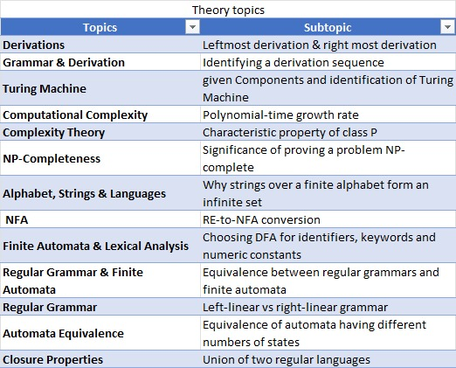

Result
The experiment successfully demonstrated the implementation and behavior of `for`, `while`, `do-while`, and enhanced `for` loops in Java. Each loop type iterated as expected, confirming their respective use cases and the successful achievement of the objective to understand iterative control flow. This foundational understanding is crucial for developing robust and efficient Java applications.

